**Task 1.2 (SQL-Oracle)**

**Stage 1:**

* Construct and ER-Diagram for the above-mentioned Requirement

* Construct Tables has per the ER-Diagram. Identify the relationships between tables and use appropriate standards for the same where applicable.

Table 1- EMPLOYEE_JOINING_STATUS

CREATE TABLE "HR"."EMPLOYEE_JOINING_STATUS"

(

"CANDIDATE_REF" NUMBER(10) PRIMARY KEY,

"STATUS" VARCHAR2(15),

CONSTRAINT fk_hr_status

FOREIGN KEY(CANDIDATE_REF) REFERENCES HR_HIRING_DETAILS(CANDIDATE_REF)

);

Employee Joining Status has the primary key as Candidate_Ref with Candidate_Ref being the foreign key from HR_HIRING_DETAILS and is a weak entity, having one to one (1-1) relationship with HR_HIRING_DETAILS implying one candidate can have the status as Joined/Not Joined.

Table 2- HR_HIRING_DETAILS

CREATE TABLE "HR"."HR_HIRING_DETAILS"

(

"CANDIDATE_REF" NUMBER(10) PRIMARY KEY,

"DOJ_EXTENDED" VARCHAR2(4),

"DURATION_TO_ACCEPT_OFFER" NUMBER(10),

"NOTICE_PERIOD" NUMBER(10),

"OFFERED_BAND" VARCHAR2(5),

"PECENT_HIKE_EXPECTED_IN_CTC" NUMBER(5,2),

"PERCENT_HIKE_OFFERED_IN_CTC" NUMBER(5,2),

"PERCENT_DIFFERENCE_CTC" NUMBER(5,2),

"JOINING_BONUS" VARCHAR2(4),

"CANDIDATE_RELOCATE_ACTUAL" VARCHAR2(4),

"GENDER" VARCHAR2(10),

"CANDIDATE_SOURCE" VARCHAR2(15),

"REX_IN_YRS" NUMBER(10),

"LOCATION" VARCHAR2(20),

"AGE" NUMBER(3),

"LOB_ID" NUMBER(1)

);

HR_HIRING_DETAILS is the master table having the primary key as Candidate_Ref and is a strong entity, having one to one (1-1) relationship with EMPLOYEE_JOINING_STATUS and one to many (1-N) relationship with LOB_MAPPING_P4.

Table 3- LOB_MAPPING_P4

CREATE TABLE "HR"."LOB_MAPPING_P4"

( "LOB_ID" NUMBER(1) PRIMARY KEY,

"LOB" VARCHAR2(15),

CONSTRAINT fk_hr_lob

FOREIGN KEY(LOB_ID) REFERENCES HR_HIRING_DETAILS(LOB_ID)

);

LOB_MAPPING_P4 has the primary key as LOB_ID with LOB_ID being the foreign key from HR_HIRING_DETAILS and is a strong entity, having one to many (1-N) relationship with HR_HIRING_DETAILS implying many candidates can have the same LOB_ID.

* Insert the appropriate data into the identified tables from the sample dataset provided.

EMPLOYEE_JOINING_STATUS

Insert into HR.EMPLOYEE_JOINING_STATUS (CANDIDATE_REF,STATUS) values (2284852,'Not Joined');

Insert into HR.EMPLOYEE_JOINING_STATUS (CANDIDATE_REF,STATUS) values (2284855,'Joined');

Insert into HR.EMPLOYEE_JOINING_STATUS (CANDIDATE_REF,STATUS) values (2284875,'Joined');

Insert into HR.EMPLOYEE_JOINING_STATUS (CANDIDATE_REF,STATUS) values (2284892,'Joined');

Insert into HR.EMPLOYEE_JOINING_STATUS (CANDIDATE_REF,STATUS) values (2284921,'Joined');

HR_HIRING_DETAILS

Insert into HR.HR_HIRING_DETAILS (CANDIDATE_REF,DOJ_EXTENDED,DURATION_TO_ACCEPT_OFFER,NOTICE_PERIOD,OFFERED_BAND,PECENT_HIKE_EXPECTED_IN_CTC,PERCENT_HIKE_OFFERED_IN_CTC,PERCENT_DIFFERENCE_CTC,JOINING_BONUS,CANDIDATE_RELOCATE_ACTUAL,GENDER,CANDIDATE_SOURCE,REX_IN_YRS,LOCATION,AGE,LOB_ID) values (2113315,'No',0,0,'E2',29.3,29.3,0,'No','Yes','Male','Direct',11,'Noida',34,2);

Insert into HR.HR_HIRING_DETAILS (CANDIDATE_REF,DOJ_EXTENDED,DURATION_TO_ACCEPT_OFFER,NOTICE_PERIOD,OFFERED_BAND,PECENT_HIKE_EXPECTED_IN_CTC,PERCENT_HIKE_OFFERED_IN_CTC,PERCENT_DIFFERENCE_CTC,JOINING_BONUS,CANDIDATE_RELOCATE_ACTUAL,GENDER,CANDIDATE_SOURCE,REX_IN_YRS,LOCATION,AGE,LOB_ID) values (2113885,'No',2,0,'E2',40,50,7.14,'No','Yes','Male','Direct',5,'Noida',32,2);

Insert into HR.HR_HIRING_DETAILS (CANDIDATE_REF,DOJ_EXTENDED,DURATION_TO_ACCEPT_OFFER,NOTICE_PERIOD,OFFERED_BAND,PECENT_HIKE_EXPECTED_IN_CTC,PERCENT_HIKE_OFFERED_IN_CTC,PERCENT_DIFFERENCE_CTC,JOINING_BONUS,CANDIDATE_RELOCATE_ACTUAL,GENDER,CANDIDATE_SOURCE,REX_IN_YRS,LOCATION,AGE,LOB_ID) values (2114740,'No',6,0,'E3',30,40.85,8.34,'Yes','No','Male','Direct',10,'Chennai',32,2);

Insert into HR.HR_HIRING_DETAILS (CANDIDATE_REF,DOJ_EXTENDED,DURATION_TO_ACCEPT_OFFER,NOTICE_PERIOD,OFFERED_BAND,PECENT_HIKE_EXPECTED_IN_CTC,PERCENT_HIKE_OFFERED_IN_CTC,PERCENT_DIFFERENCE_CTC,JOINING_BONUS,CANDIDATE_RELOCATE_ACTUAL,GENDER,CANDIDATE_SOURCE,REX_IN_YRS,LOCATION,AGE,LOB_ID) values (2114758,'Yes',37,90,'E1',99,77.86,-10.6,'No','No','Male','Direct',4,'Bangalore',28,4);

Insert into HR.HR_HIRING_DETAILS (CANDIDATE_REF,DOJ_EXTENDED,DURATION_TO_ACCEPT_OFFER,NOTICE_PERIOD,OFFERED_BAND,PECENT_HIKE_EXPECTED_IN_CTC,PERCENT_HIKE_OFFERED_IN_CTC,PERCENT_DIFFERENCE_CTC,JOINING_BONUS,CANDIDATE_RELOCATE_ACTUAL,GENDER,CANDIDATE_SOURCE,REX_IN_YRS,LOCATION,AGE,LOB_ID) values (2114973,'No',3,60,'E1',125,105,-8.89,'No','No','Male','Employee Referral',2,'Noida',26,5);

LOB_MAPPING_P4

Insert into HR.LOB_MAPPING_P4 (LOB_ID,LOB) values (1,'ERS');

Insert into HR.LOB_MAPPING_P4 (LOB_ID,LOB) values (2,'INFRA');

Insert into HR.LOB_MAPPING_P4 (LOB_ID,LOB) values (3,'Healthcare');

Insert into HR.LOB_MAPPING_P4 (LOB_ID,LOB) values (4,'BFSI');

Insert into HR.LOB_MAPPING_P4 (LOB_ID,LOB) values (5,'CSMP');

**Stage 2:**

* Generate Info those candidates who have accepted offer and joining time is less then 30 days and candidates who are ready to re-locate.

select * from hr_hiring_details join employee_joining_status using(candidate_ref)

where status='Joined' and notice_period<30 and candidate_relocate_actual='Yes';

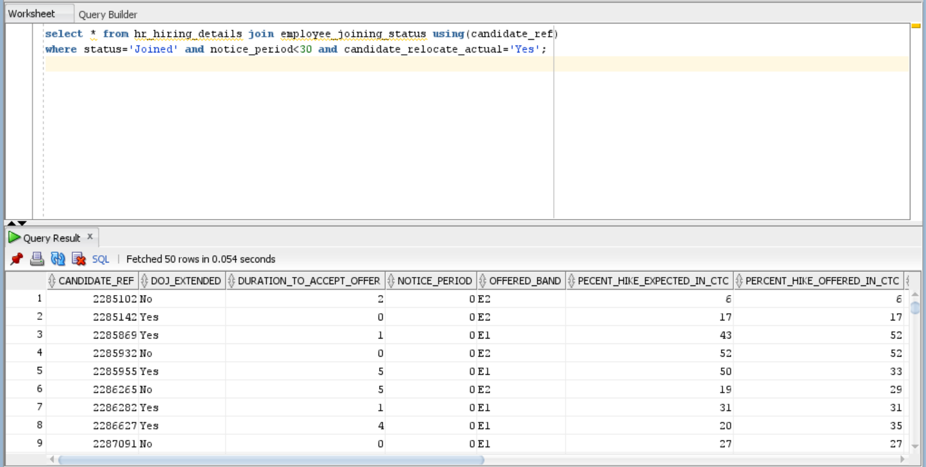

* Generate Info those candidates who have accepted offer and also display list the candidates who have been offered and yet to accept the offer within 10 days;

select * from hr_hiring_details join employee_joining_status using(candidate_ref)

where status='Joined' and duration_to_accept_offer<=10;

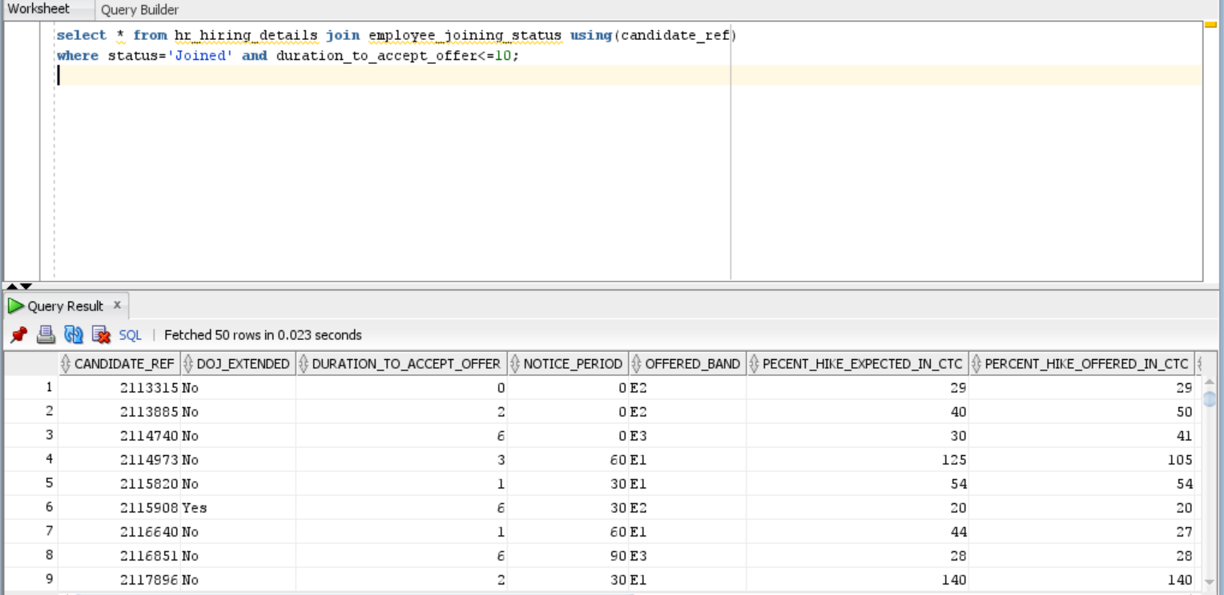

* Generate Info those candidates who are willing to join and the ECTC is 25% hike from their CTC.

select * from hr_hiring_details join employee_joining_status using(candidate_ref)

where status='Joined' and percent_difference_ctc=25;

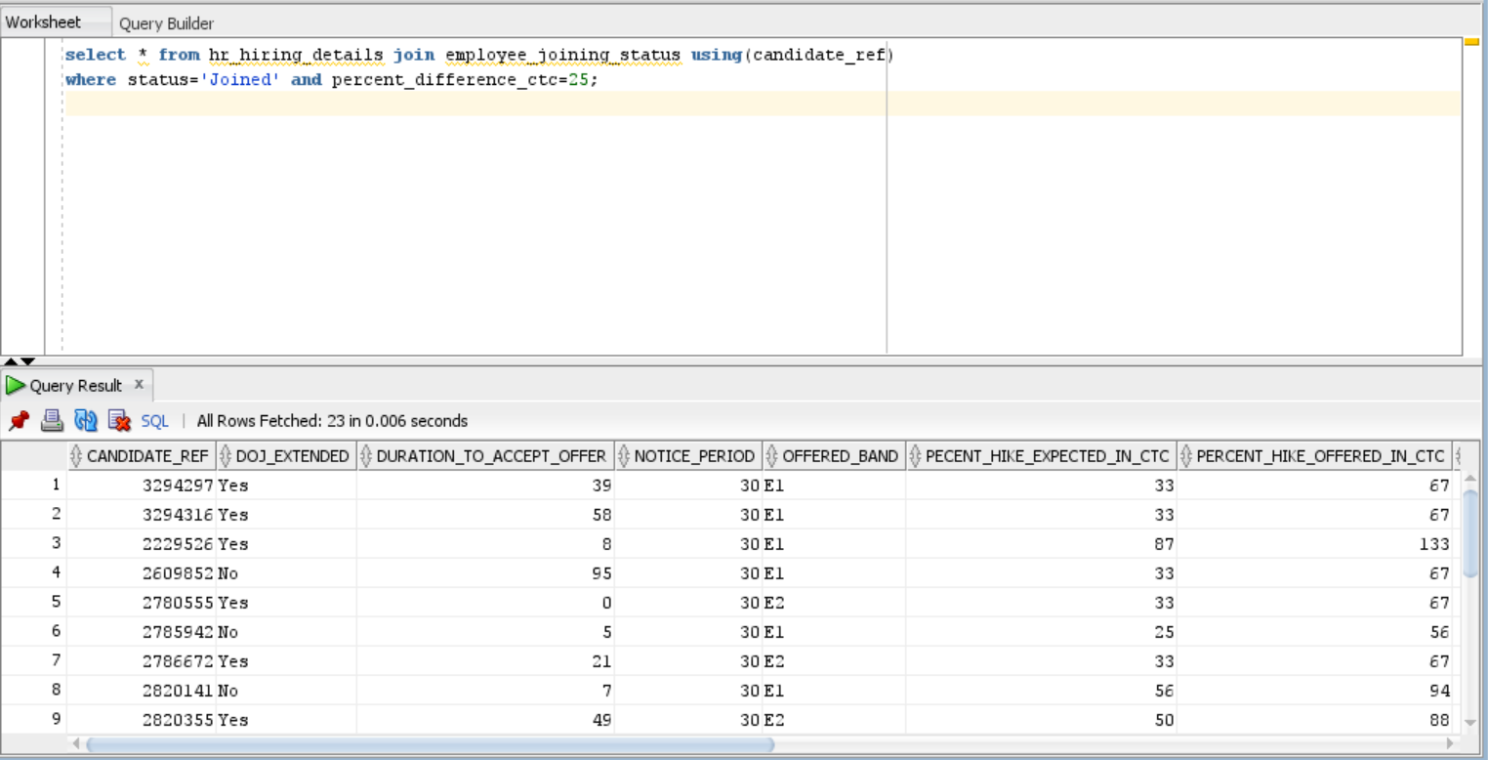

* Generate Info those candidates who are willing to join and the ECTC is 25% hike from their CTC joining time is less then 30 days and candidates who are ready to re-locate and joining bonus is offered.

select * from hr_hiring_details join employee_joining_status using(candidate_ref)

where status='Joined' and percent_difference_ctc=25 and notice_period<30 and candidate_relocate_actual='Yes' and Joining_bonus='Yes';

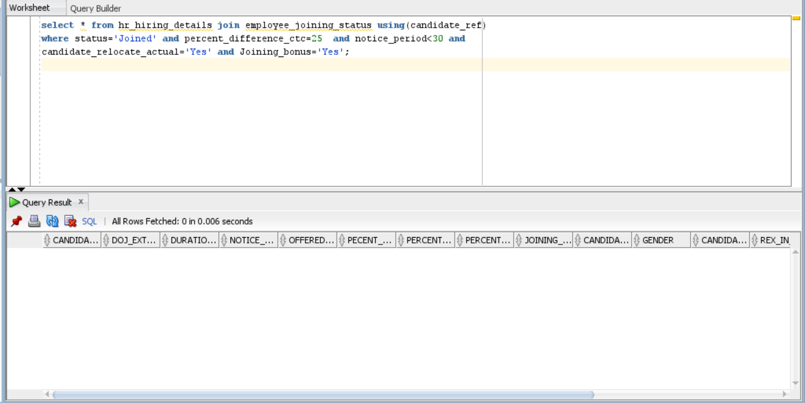

* Generate the count of the candidates who are hired through what source and also who have joined and declined the offer.

select candidate_source,status, count(candidate_ref) count from hr_hiring_details join employee_joining_status using (candidate_ref) group by (candidate_source,status) order by candidate_source;

